Cloud API | Custom application development
(Setup an instance with java, associate appropriate IAM role, leverage java S3 & Kinesis api and build an application, use Kinesis RT analytics capability)

List Of Tasks
- Configure a Java Application to pump json files to Kinesis
- Create Kinesis Stream to capture streaming data
- Perform Real-Time Analytics on Streaming Data

1. Create the JAR file of the DataPump application and TARBALL of its Libraries

Install Java Eclipse Photon .

Then in Eclipse IDE, go to Help > Install New Software and add this link in the URL bar to get all packages for AWS ToolKit.

Project Name : DataPump, select Amazon Kinesis Sample and click Finish. AWS Credentials : default

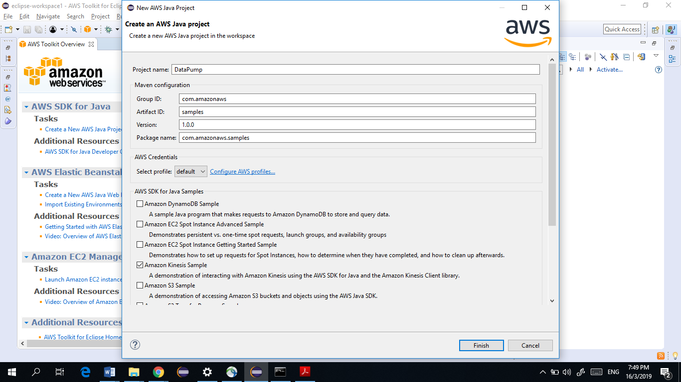
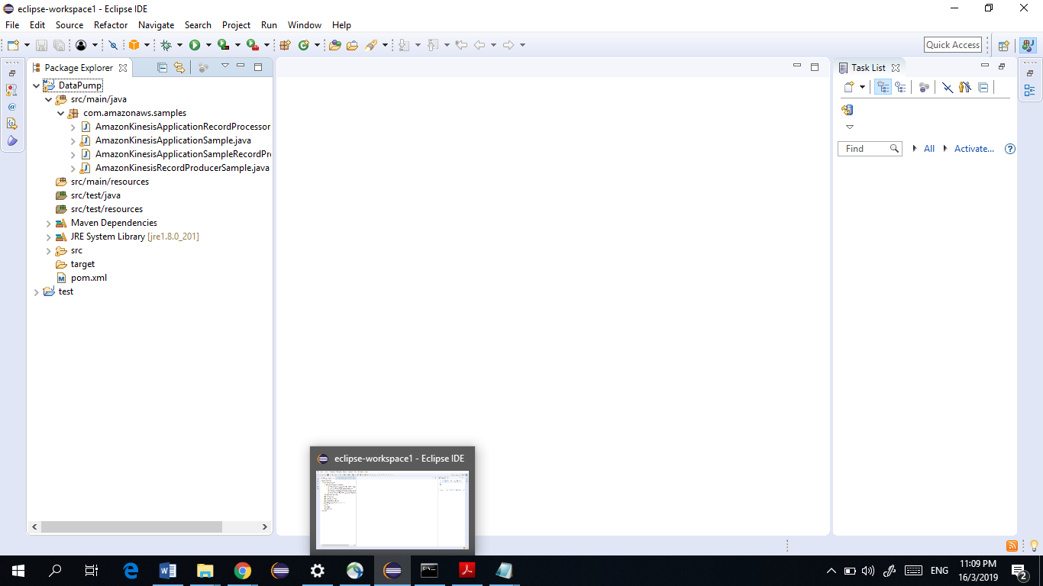

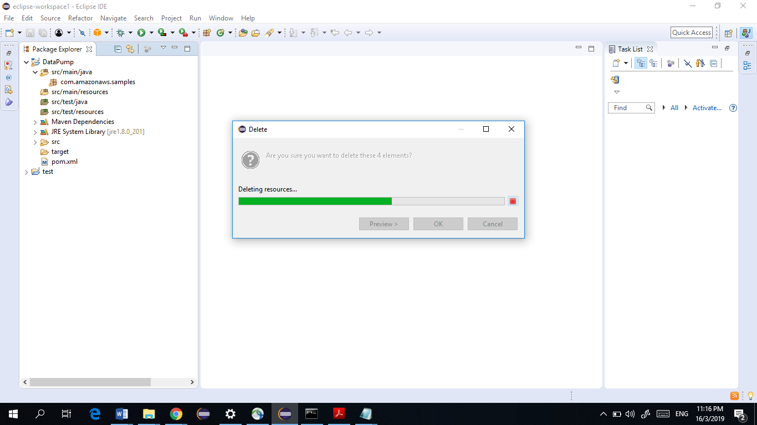

Create a new public class DataPump in the same package

Click Finish and Copy the contents of the DataPump.java file you downloaded into this Class.

Right click on com.amazonaws.samples and go to Refactor > Rename

Then rename your package to com.gl.cloud.pump
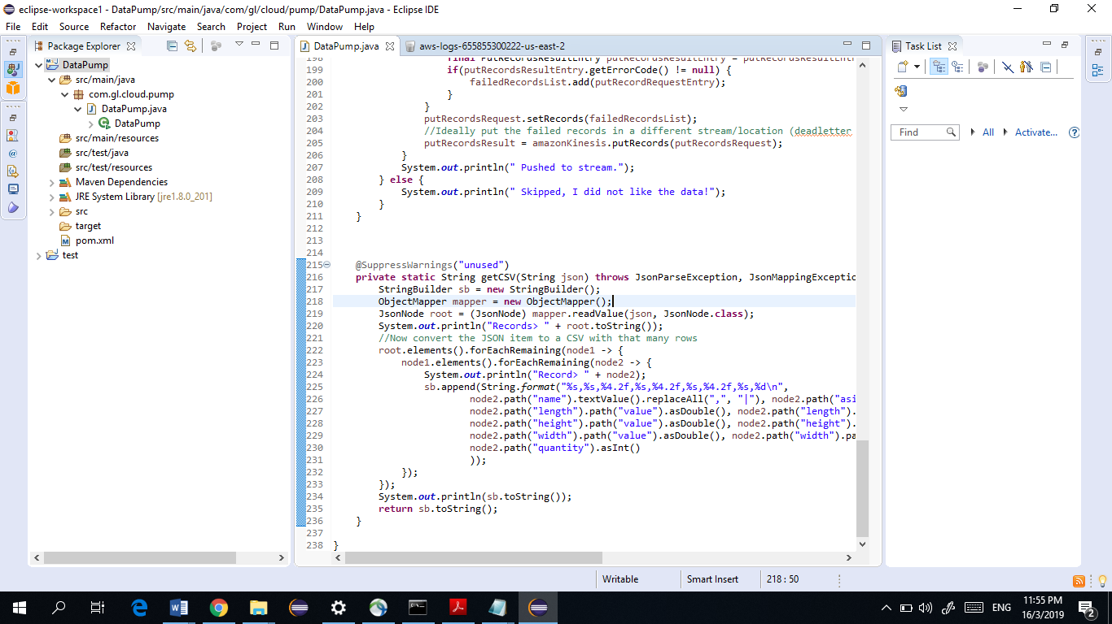
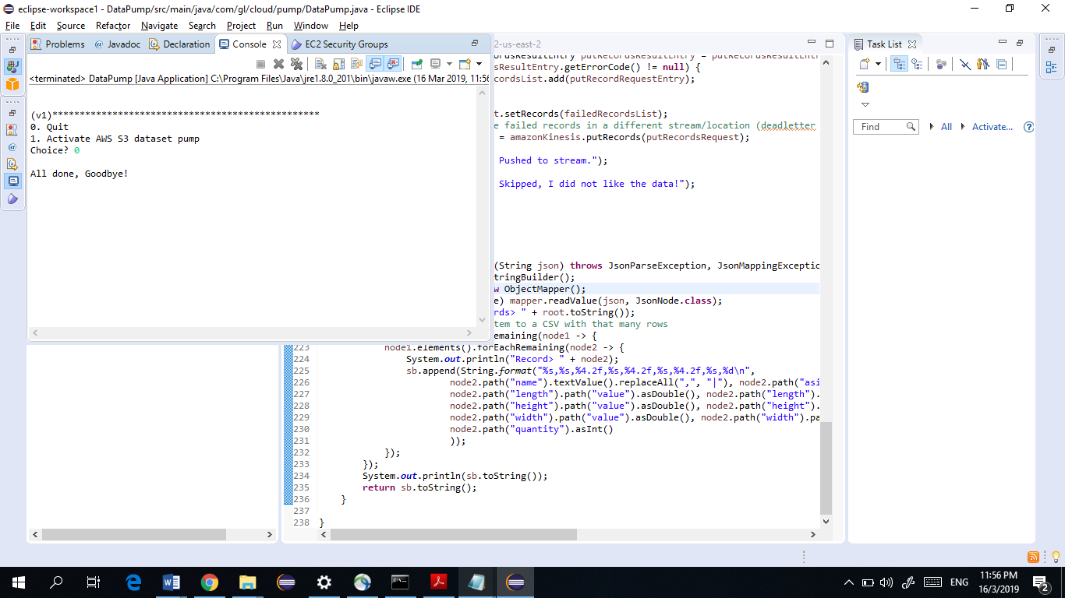

Right click on your project Data Pump and select Export > Java > Runnable Jar File > Next

In Launch Configuration, Select DataPump.
In Export Destination, locate your current eclipse workspace > DataPump > Rename DataPump.jar
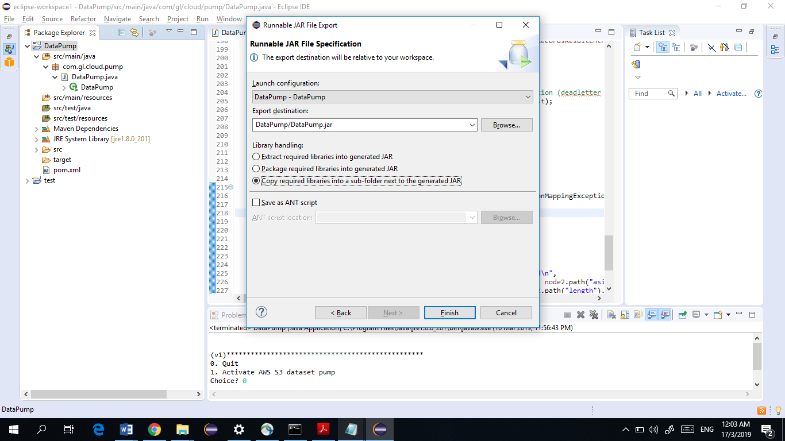

Select Copy required libraries into a sub folder next to the generated JAR, and click Finish to create the JAR in the specified location.

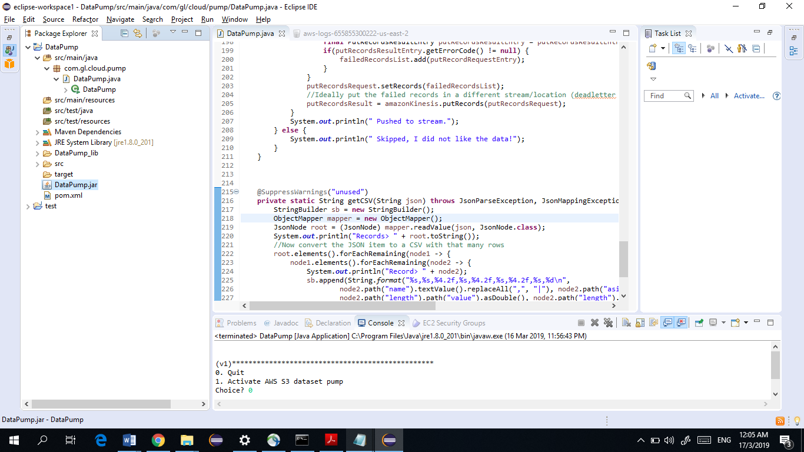

Locate to your workspace folder for DataPump, and right click on DataPump_lib and click on Compress.

Compress it in the format of .tar.gz

We would later need to SCP the file into our EC2 instance which we will be creating next.
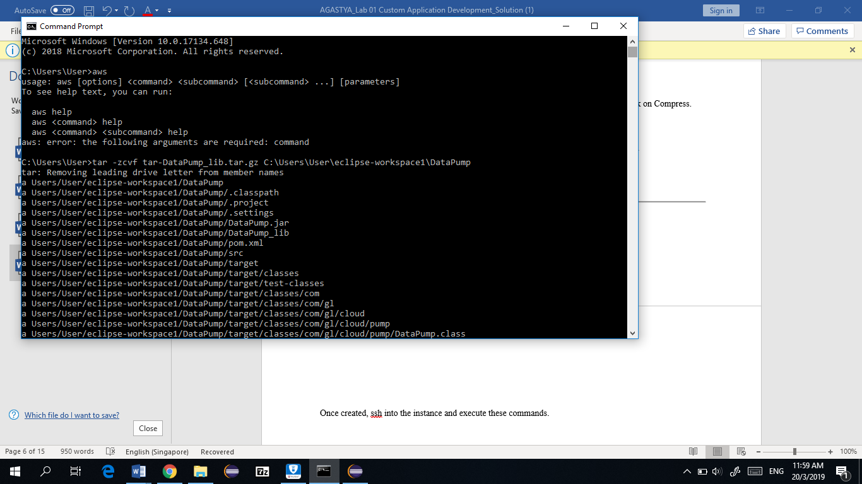

2. Create the EC2 Web Server and upload required Files

Create an EC2 Instance with these configuration.

1. AMI : Ubuntu LTS 16.04 2. Instance Type : t2.small 3. Tags :
a. Name : kinesis-datapump
4. IAM Role : Contains two policies
  - S3FullAccess
  - KinesisFullAccess

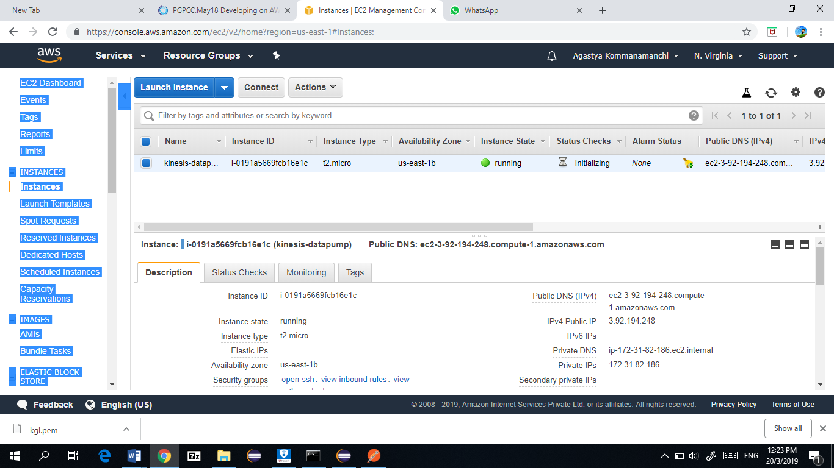

Once created, ssh into the instance and execute these commands.

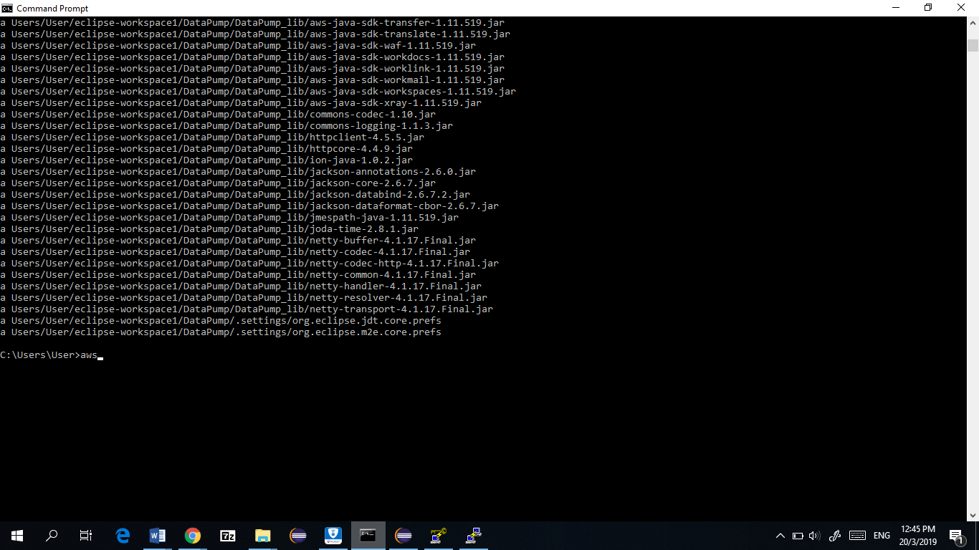

sudo apt update
sudo apt install unzip ant python-pip
sudo pip install --upgrade --user awscli
sudo apt install awscli
sudo chown ubuntu:ubuntu -R /opt
cd /opt

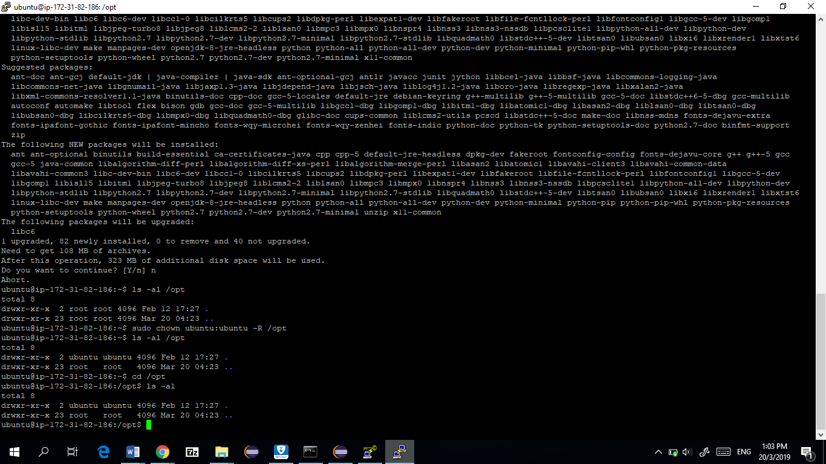

Installing JDK 8.

wget --no-check-certificate --no-cookies --header "Cookie: oraclelicense=accept-securebackup-cookie"
<copied_link_location_of_jdk> | https://download.oracle.com/otn-pub/java/jdk/8u201-b09/42970487e3af4f5aa5bca3f542482c60/jdk-8u201-linux-x64.tar.gz
Navigate to the Java SE Development Kit 8 Downloads Website. Accept the License Agreement of the Java SE Development Kit 8u201 and copy the Link Location of Linux x64 version.

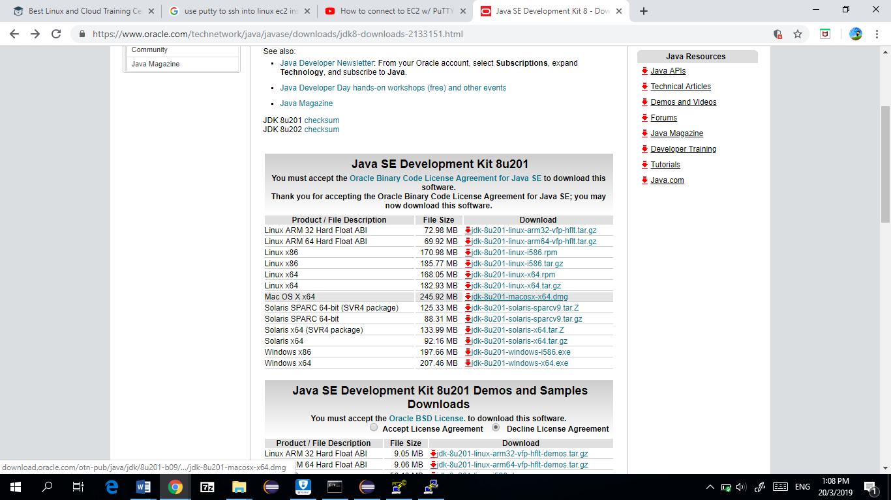

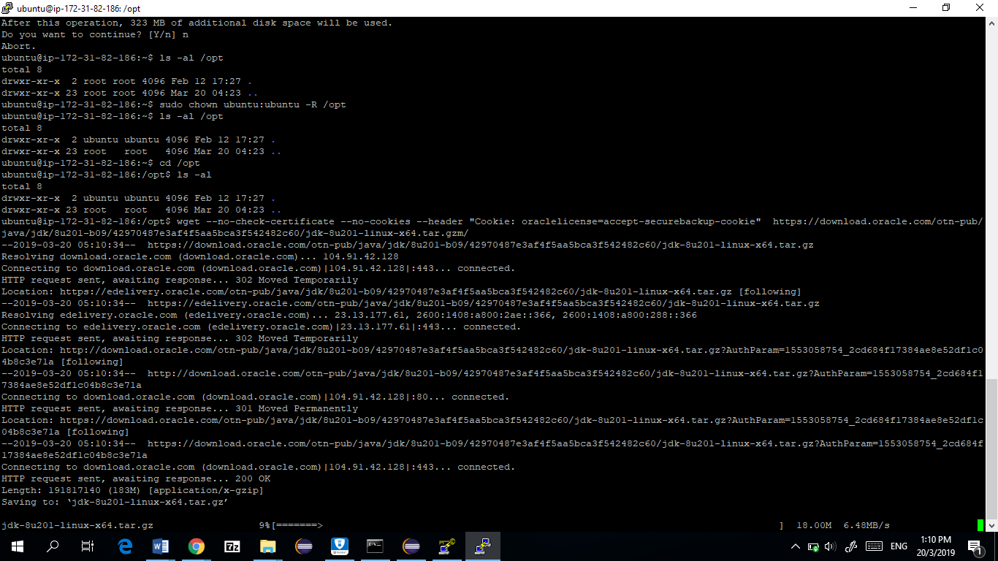

Once downloaded, untar it with this command

tar -zxf jdk-8u201-linux-x64.tar.gz
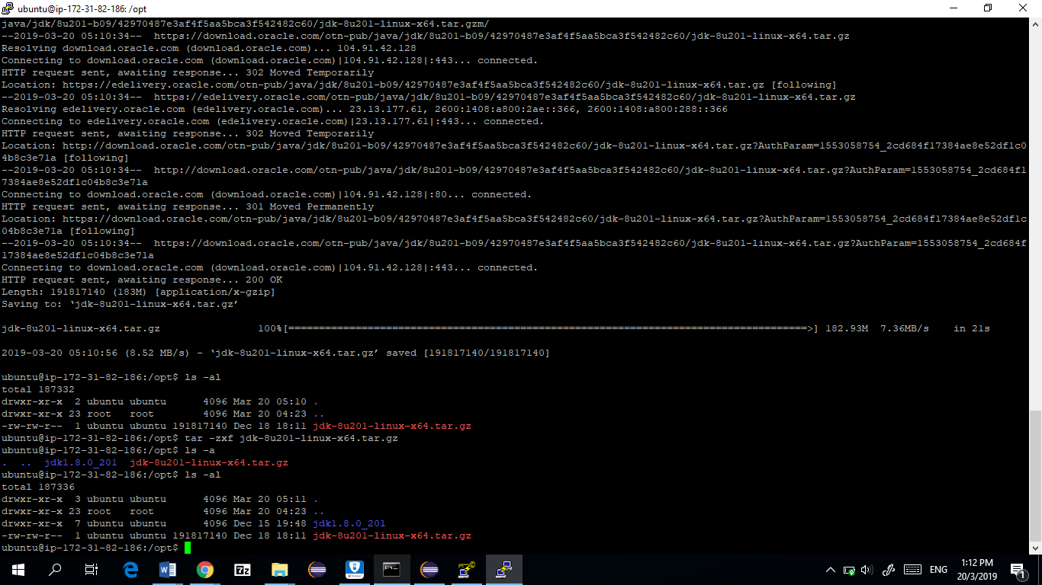

Update JAVA_HOME environment variable
nano ~/.profile

And update it with these lines
export JAVA_HOME=/opt/jdk1.8.0_201
PATH="$JAVA_HOME/bin:$PATH |  | "

source ~/.profile.

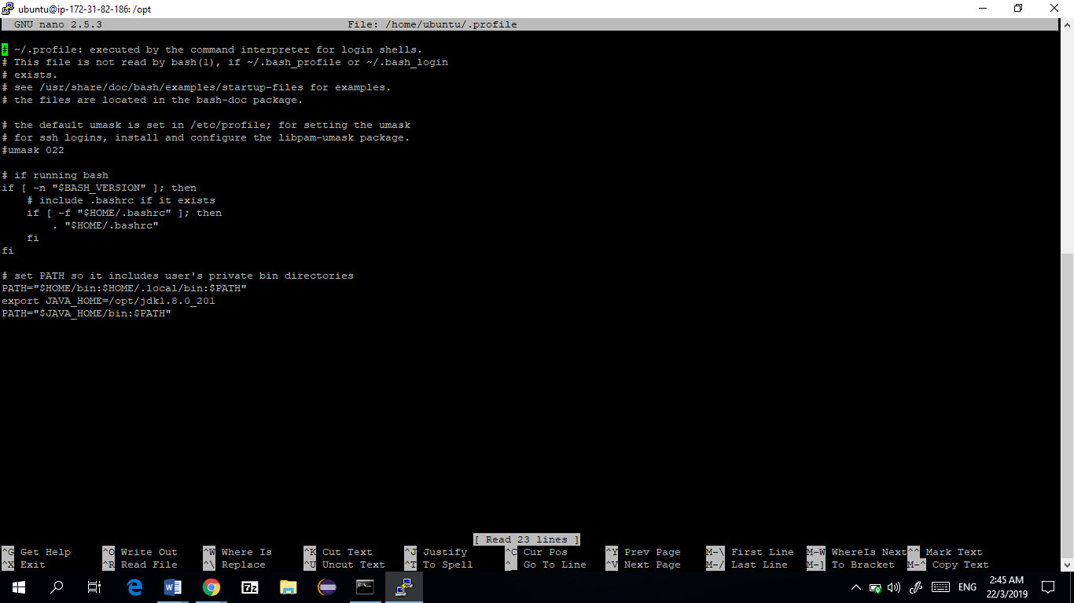
Check if it worked by issuing this command

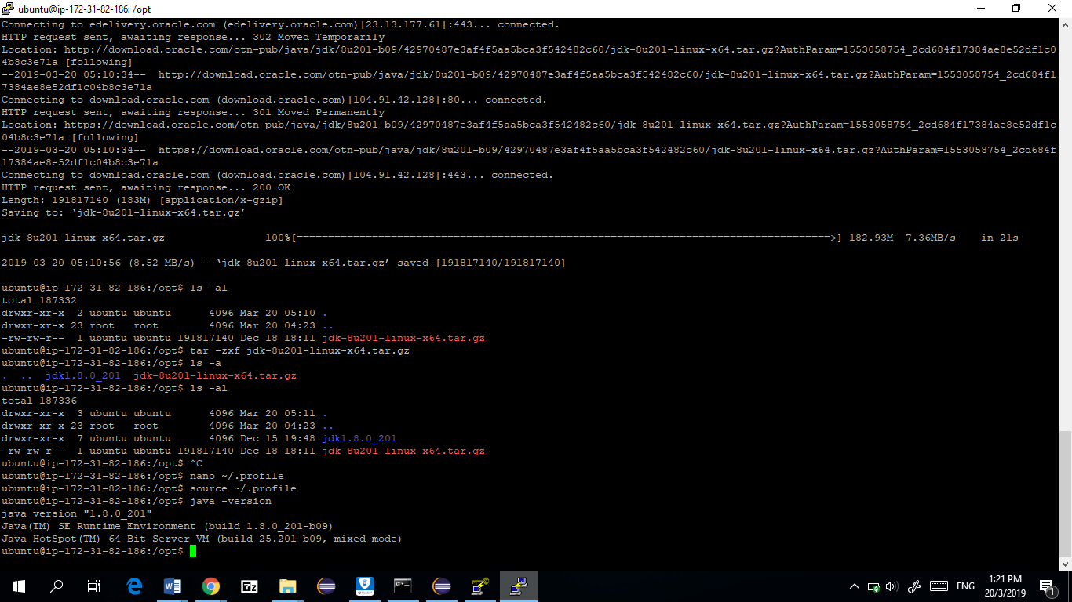

Now, make a new folder called pump and change into the pump folder

mkdir pump
cd pump/

Open a terminal in your local laptop and navigate to DataPump folder in your Workspace.

We need to SCP files from here to our EC2 instance.

Syntax :

scp -i <key> <file_to_send> <aws_hostname>@<aws_public_ip>:<path_to_save>
scp -i kgl.pem DataPump.jar ubuntu@52.90.177.142:/opt/pump

Send our JAR file and TARBALL file to location /opt/pump on our EC2 instance.

- Creating the Kinesis Stream and Analytics Application
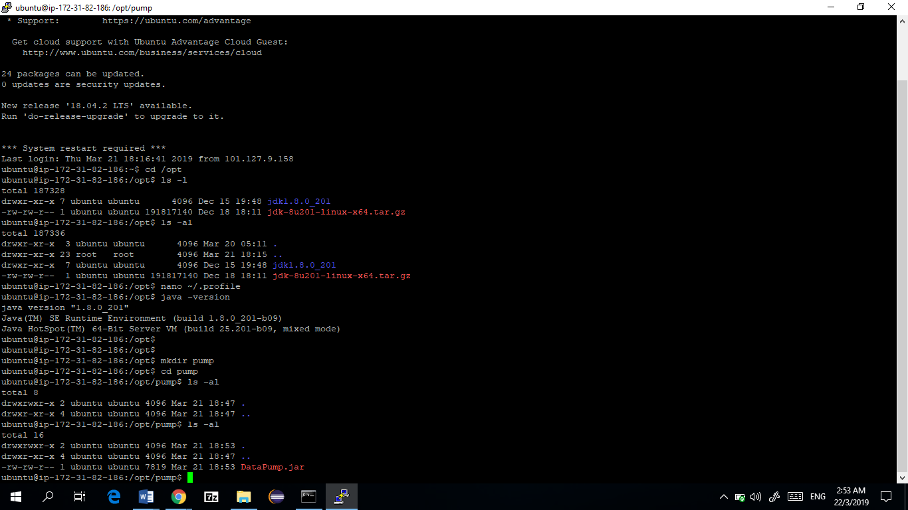
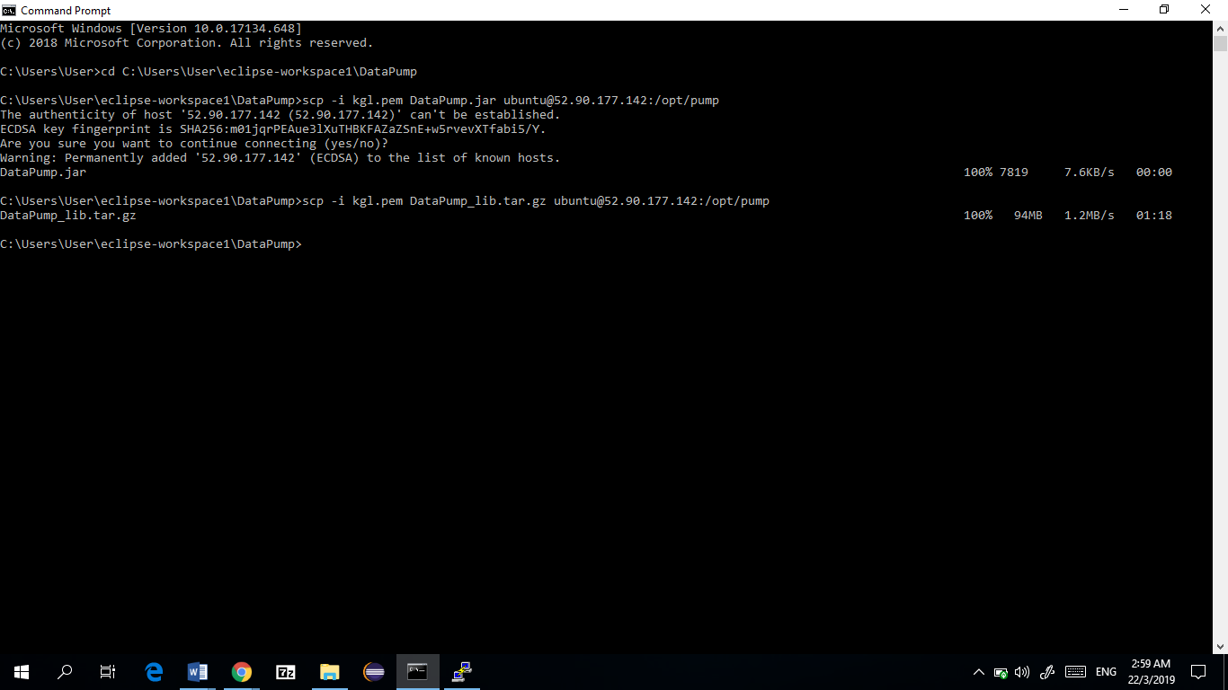
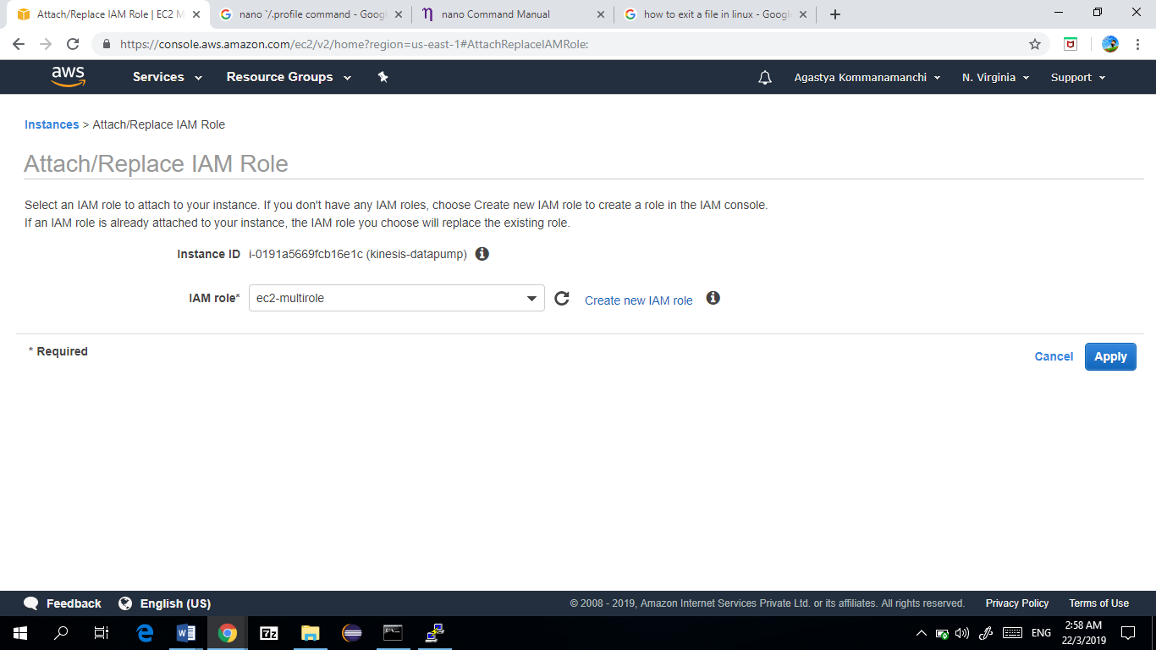

Go to Console > Kinesis Streams > Create Data Stream

Name : product-stream
No. of shards : 1

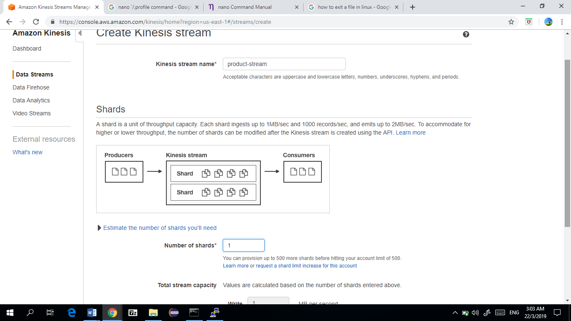
Click on Create Data Stream.

Go to /opt/pump in your EC2 instance and execute this command
tar -zxf DataPump_lib.tar.gz

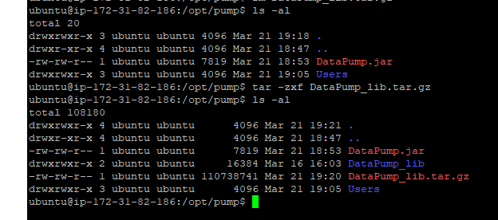

mkdir data

Execute the application by issuing this command.

Test it out.
Choice : 1
Data files to pump : 1

Press Enter and quit application by issuing 0 as argument.
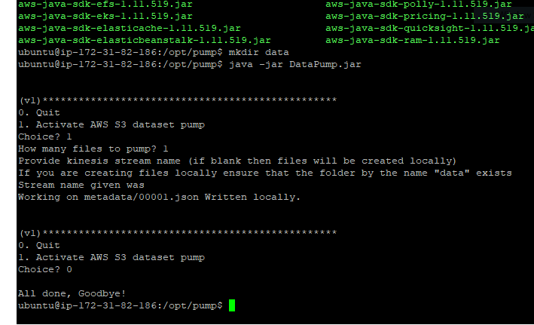

Here we can see the json file that was created.
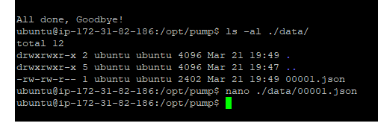
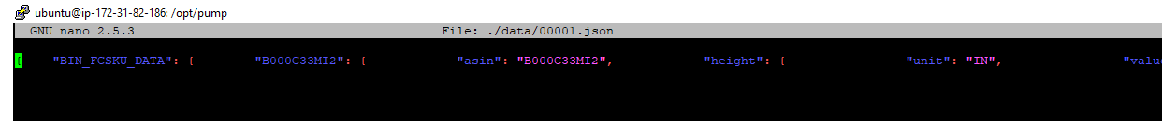
On the left pane, click Data Analytics > Create Application

Application Name:product analyser
Description : Looks at the stream and gauges the change
Click on Source > Connect Streaming Data

Source : Kinesis Stream
Kinesis Stream : product-stream
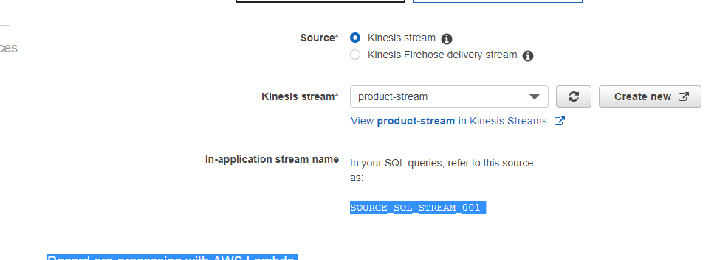

We need to pump data into the stream before we can detect its Schema.

Go to your EC2 instance and issue the command to run the jar file.

Choice : 1
Files to pump : 10
Kinesis Stream : product_stream

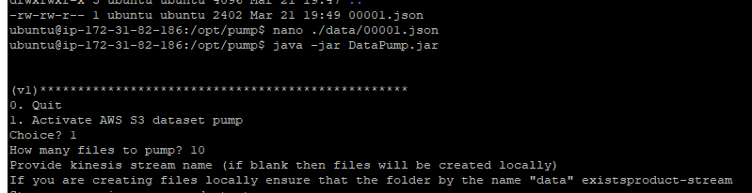

The records will successfully be created and pushed in the stream
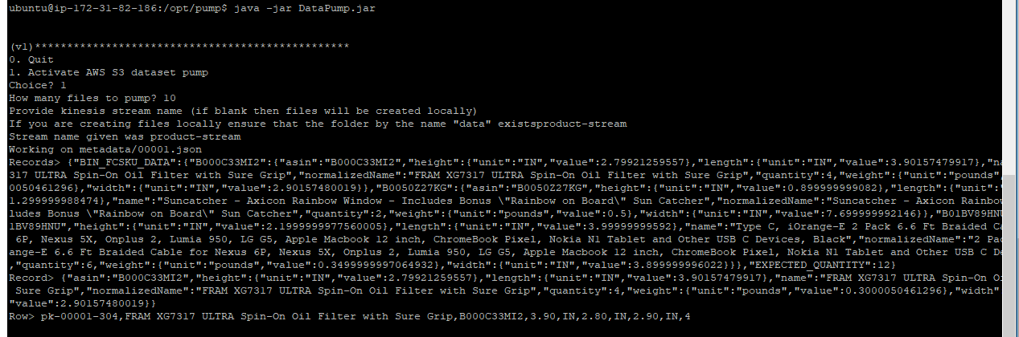

Finally, click on Discover Schema to start Schema Discovery.

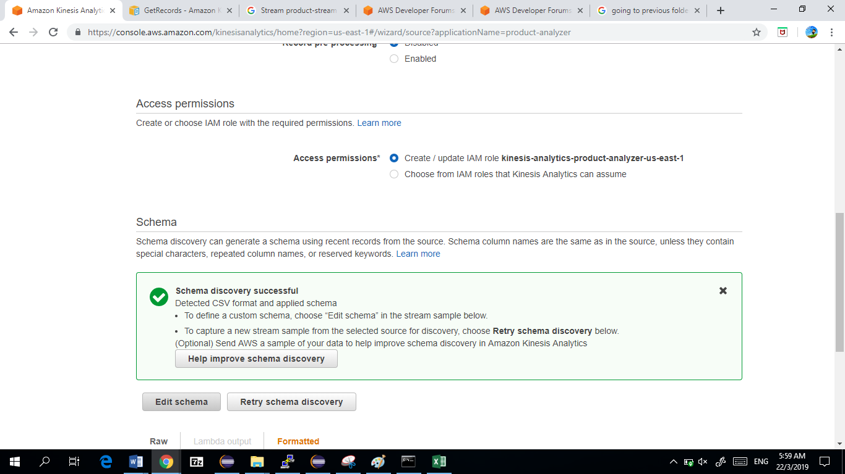
Click on Edit Schema and delete everything beyond 9.

Modify the next page according to this screenshot below.

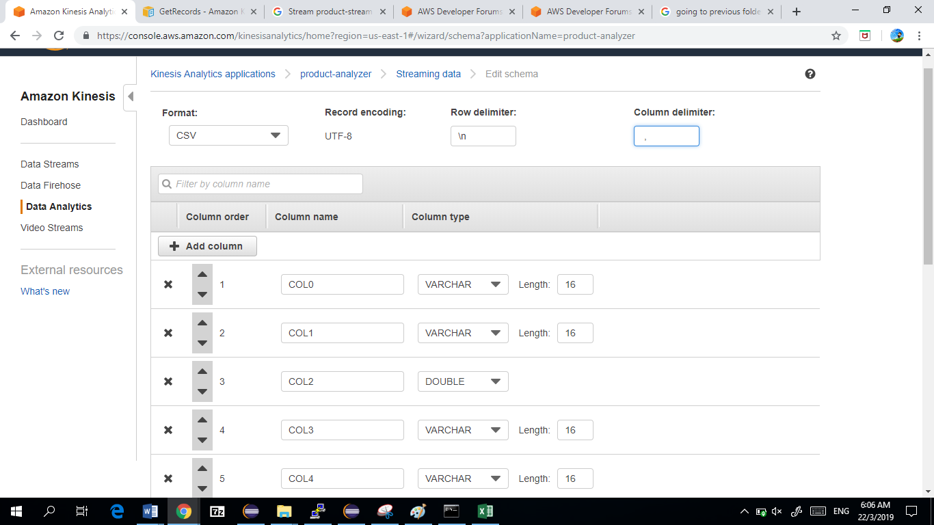
Click Save Schema and Update Stream Samples to finish creating the application.

As soon as you click Save Schema and Update Stream Samples, the application is going to start initializing and will wait for you to input more data into the stream.

Re-run the application to insert 100 rows in product-stream.

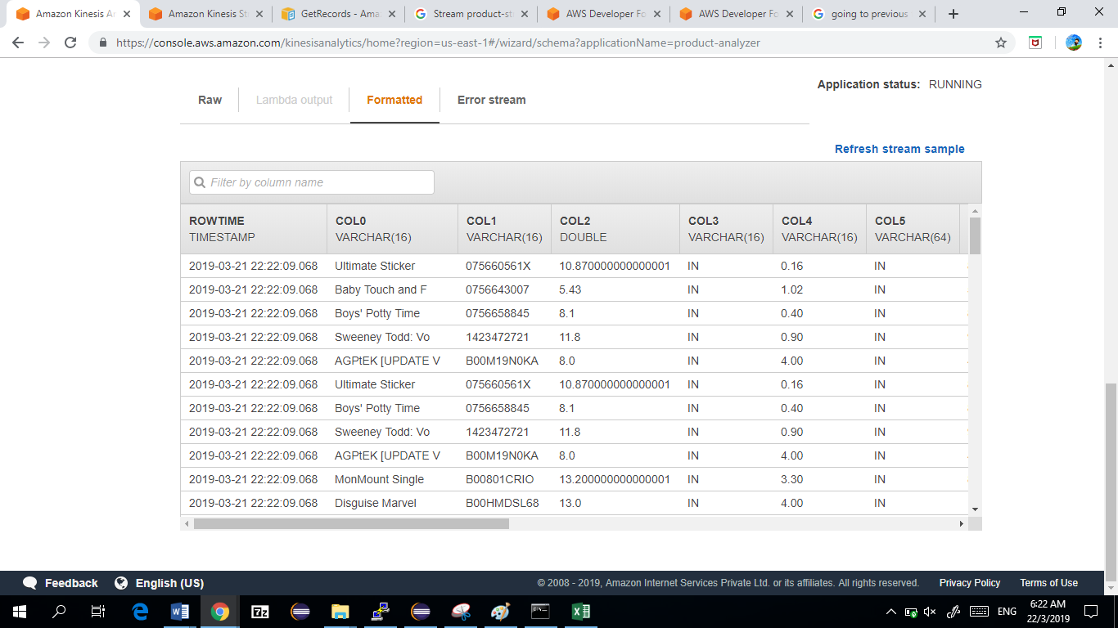

Click on Exit >Save and Continue

3. Real Time Analytics

Next, click on Go to SQL Editor in Real Time Analytics

Copy and paste the SQL Query below in the editor.

We are going to match products that have the black keyword in them.

CREATE OR REPLACE STREAM "DESTINATION_SQL_STREAM" (col0 VARCHAR(16), col1 VARCHAR(12),
col3 VARCHAR(12), col2 DOUBLE);

CREATE OR REPLACE PUMP "STREAM_PUMP" AS INSERT INTO "DESTINATION_SQL_STREAM"

SELECT STREAM col0,col1,col3,col2
FROM "SOURCE_SQL_STREAM_001"

WHERE col0 SIMILAR TO '%lack%';

Click on Save and Run SQL in our application. Go to our Java application in EC2, and starting pumping 500 records in the product-stream.

We can see our streaming data getting classified into only rows containing ‘lack’ in the COL0 column here.
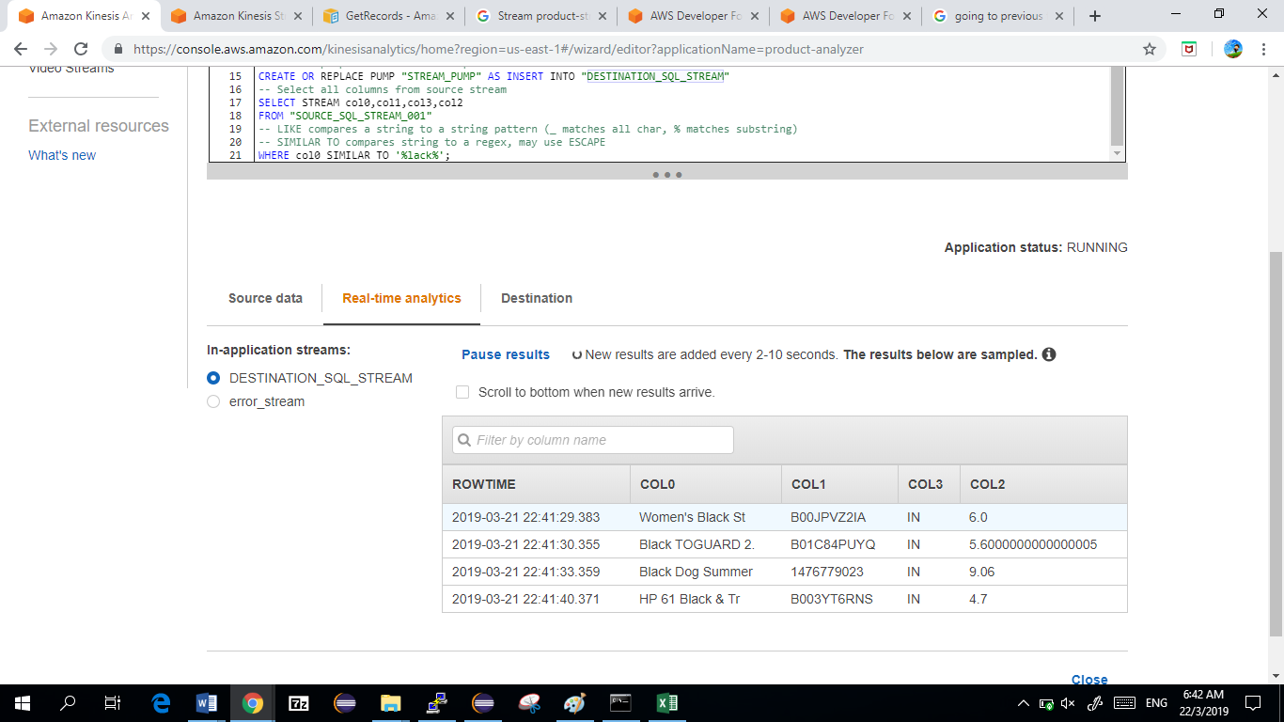

OBSERVATIONS

- Created JAR file of Application and executed it on AWS EC2
- Used the application to pump data to Kinesis Stream
- Captured Data in real-time from Kinesis Stream into Analytics Application and perform Analytics upon it.

Lab cleaning

Deleting the stream

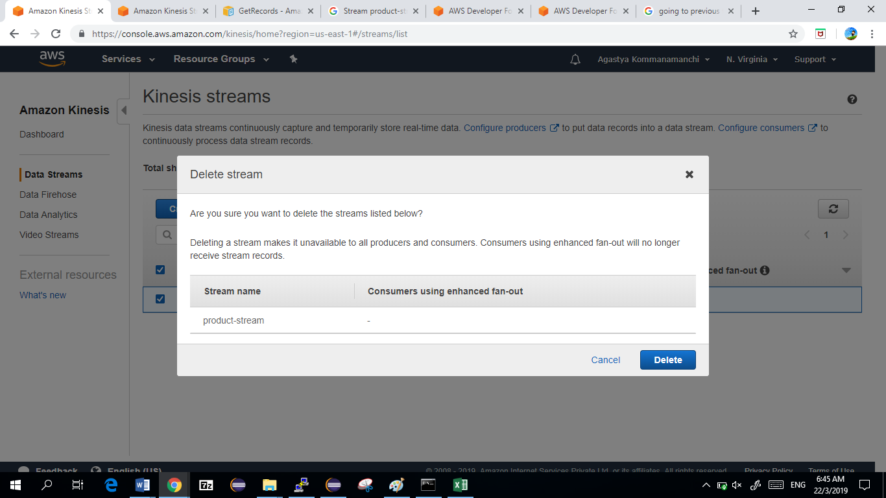
Deleting the Analyzer

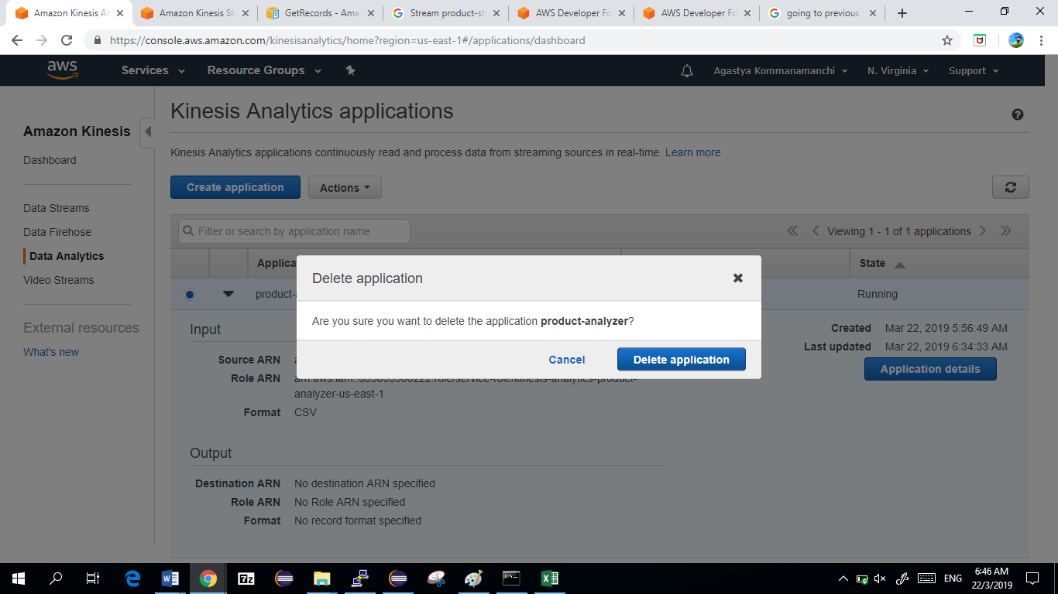

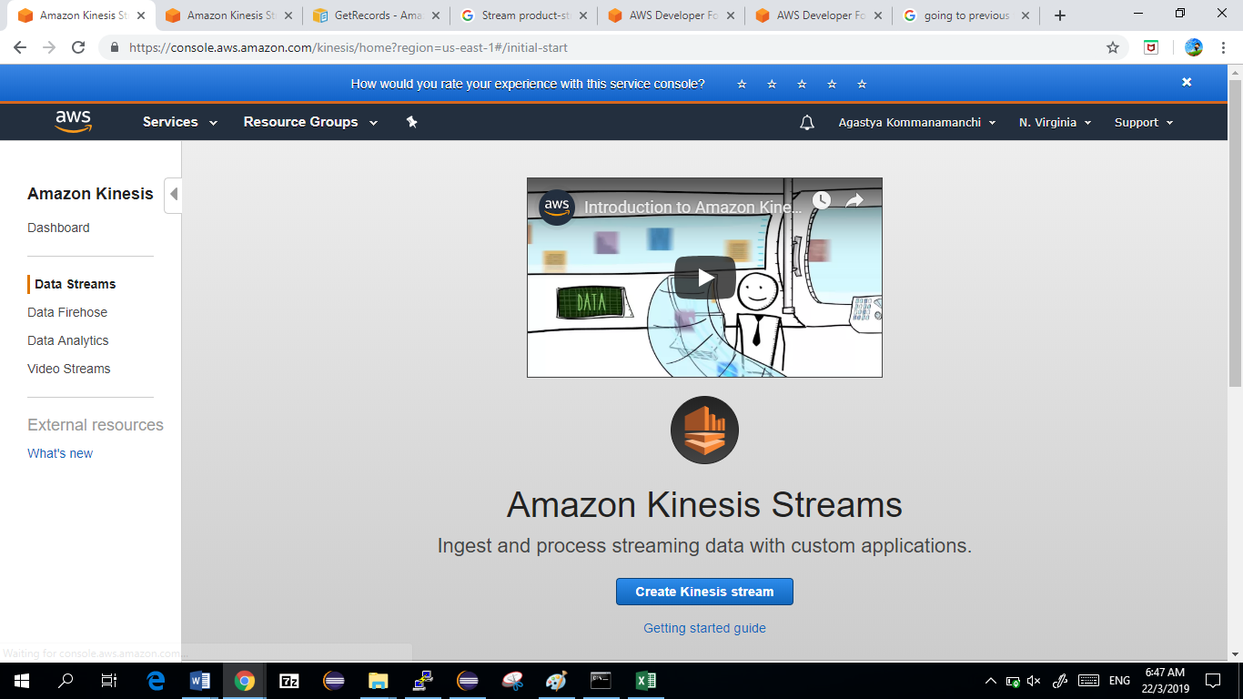

Deleting The instance

